

Data Science

Analysing Suicides in India

Aekansh Dixit

PES1201701808 (3C)

# **Introduction**

I decided to analyse the Suicides In India from 2001 to 2012 and inferred some meaningful insights from the data gathered. The data set was downloaded from the internet and underwent cleaning in order to properly understand the analytics. There are both categorical data, as well as numeric data making it a challenge to properly interpret the same.

## The Project Details

Dataset: [Suicides In India](https://www.kaggle.com/rajanand/suicides-in-india) (2001 - 2012)

Programming Language Used: R in RStudio

GitHub Link: [Crazytics - Suicides In India](https://github.com/aekanshd/crazytics-suicidesIndia)

**Total Rows: 238,000**

**Total Columns: 7**

|  |  |  |  |  |  |  |
| --- | --- | --- | --- | --- | --- | --- |
| **State** | **Year** | **Type_code** | **Type** | **Gender** | **Age_group** | **Total** |
| **A & N Islands** | **2001** | **Causes** | **Illness (Aids/STD)** | **Female** | **0-14** | **0** |
| **A & N Islands** | **2001** | **Causes** | **Bankruptcy or Sudden change in Economic** | **Female** | **0-14** | **0** |
| **A & N Islands** | **2001** | **Causes** | **Cancellation/Non-Settlement of Marriage** | **Female** | **0-14** | **0** |
| **A & N Islands** | **2001** | **Causes** | **Physical Abuse (Rape/Incest Etc.)** | **Female** | **0-14** | **0** |
| **A & N Islands** | **2001** | **Causes** | **Dowry Dispute** | **Female** | **0-14** | **0** |

**The Dataset Downloaded in CSV**

## 

## Gathering and Understanding the Dataset

The dataset can be downloaded from the given link above. Upon opening the **.csv** file, we realise the format of the dataset:

It seems to have 7 columns, namely:

1. **State** in which the data was recorded.
2. **Year** in which the data was recorded.
3. **Type_Code** is the type of data recorded, which can be broken into:
   1. **Causes:** The cause of the suicide.
   2. **Education Status:** The education status of the profile.
   3. **Means Adopted:** How did the profile commit suicide?
   4. **Professional Profile:** What was the professional status of the profile?
   5. **Social Status:** Was the profile married/divorced/Never Married, etc?
4. **Type** is the information of the categorical data presented in **3**.
5. **Gender** is the sex of the profile.
6. **Age Group** is the age group the profile falls under.
   1. **0-14**
   2. **15-29**
   3. **30-44**
   4. **45-59**
   5. **60+**
   6. **0-100+** is the special category for the profiles testing **Education Status** and **Social Status**.
7. **Total** is the number of profiles that committed suicide under that category.

Going through the dataset, it is clear that a lot of categorical data is clustered and that we need to clean the data in order for us to find some meaningful analysis. The only column that needs to be focused on is **Total**.

## 

## Questions to Answer

We’ll be looking to answer 3 different questions using this dataset:

1. What is the trend of suicides committed by the females in India over the years?
2. Which age group is more prone to commit suicides?
3. What is the major cause of suicides in India?

# Getting Started

## First Steps in R

As already guessed, the first step in R is to import the dataset. Thankfully, R makes it really easy to import CSV datasets. But before we do that, we need to install a few packages that we’ll require later:

|  |  |  |  |  |  |  |  |  |  |  |  |  |  |  |  |  |  |  |  |  |  |  |  |  |  |  |  |  |  |  |  |  |  |  |  |  |  |  |  |  |  |  |  |  |  |  |  |  |  |  |  |  |  |  |  |  |
| --- | --- | --- | --- | --- | --- | --- | --- | --- | --- | --- | --- | --- | --- | --- | --- | --- | --- | --- | --- | --- | --- | --- | --- | --- | --- | --- | --- | --- | --- | --- | --- | --- | --- | --- | --- | --- | --- | --- | --- | --- | --- | --- | --- | --- | --- | --- | --- | --- | --- | --- | --- | --- | --- | --- | --- | --- |
| > install.packages("dplyr") > install.packages("magrittr") > install.packages("lubridate") > install.packages("zoo") > install.packages("ggplot2") > install.packages("ggpubr") > install.packages("car") > install.packages("fastDummies")  Now that we have our packages ready, we’re ready to begin. Let’s go ahead and import our csv into a dataframe in R.  > library(dplyr) > library(magrittr)  # Import Dataset > dataset <- read.csv("dataset.csv")  Now, let’s select a few columns and see their listing in RStudio:  # Select State (Karnataka), Type, and Total Deaths  > dataset %>%  + select(State,Type,Total) %>%  + filter(State == "Karnataka") %>%  + head()  This will give us the following output:   |  |  |  |  | | --- | --- | --- | --- | |  | State | Type | Total | | 1 | Karnataka | Insanity/Mental Illness | 11 | | 2 | Karnataka | Causes Not known | 42 | | 3 | Karnataka | Property Dispute | 0 | | 4 | Karnataka | Drug Abuse/Addiction | 5 | | 5 | Karnataka | Cancer | 0 | | 6 | Karnataka | Fall in Social Reputation | 0 |   Now that our CSV is working properly, let’s move on to the next step. Checking for missing value In order to check for the missing data, we will take the help of this code:  # Check for missing values  > apply(dataset, 2, function(x) any(is.na(x)))  This will show the following output:   |  |  |  |  |  |  |  | | --- | --- | --- | --- | --- | --- | --- | | **State** | **Year** | **Type_code** | **Type** | **Gender** | **Age_group** | **Total** | | FALSE | FALSE | FALSE | FALSE | FALSE | FALSE | FALSE |   What this means is that our dataset is complete and there are no missing values. However, for the sake of this project demonstration, we will **deliberately** delete a few values in our dataset.  The best column that qualifies for this manipulation is the gender since   1. Age_group is a groups together multiple profiles. (Grouped data) 2. Total counts the number of deaths by that type_code. (Grouped data) 3. Type_Code in turn is used to find out the profile of the person. (Grouped data)   Let’s first find out the number of entries in our dataset:  # Find out number of entries > nrow(dataset) [1] 237519  We will now remove **10% of our data randomly**, which means we will remove 23715 rows of data.  To select 10% of data randomly, we execute this:  # take 10% sample > sampleData <- dataset[sample(nrow(dataset), 0.1*nrow(dataset)), ] > sampleDataRowNumbers <- as.numeric(rownames(sampleData))  The second line extracts the row numbers of the sampled data. We will use these row numbers to delete data from the original dataset. But before we proceed, let’s check the size of this dataset.  # Find out number of entries in sample nrow(sampleData) [1] 23751  This number is in sync with the number we calculated earlier, so we are on the right track. Let’s proceed by deleting these values from the original dataset.  # Delete the data from 5th column > dataset[sampleDataRowNumbers,5] <- NA  This line will make all the sampled rows’ **gender** column as NA. Let’s go ahead and test for the missing values once again.  # Check for missing values  > apply(dataset, 2, function(x) any(is.na(x)))   |  |  |  |  |  |  |  | | --- | --- | --- | --- | --- | --- | --- | | **State** | **Year** | **Type_code** | **Type** | **Gender** | **Age_group** | **Total** | | FALSE | FALSE | FALSE | FALSE | **TRUE** | FALSE | FALSE |   Notice how the “Gender” column now shows TRUE, which means we have some missing values. Dealing with missing values The [Project Guidelines](https://github.com/aekanshd/crazytics-suicidesIndia/blob/master/Project%20Guidelines%20.pdf) states that:   * All the NAN’s for categorical columns to be replaced with its previous row values. **(1 mark)** * All the NAN’s for numeric columns to be replaced with average of the column. **(1 mark)** |

Before we do so, let’s view our missing value data:

# View all the columns of the sample data  
> dataset[sampleDataRowNumbers,]

This will output the following:

|  |  |  |  |  |  |  |
| --- | --- | --- | --- | --- | --- | --- |
| **State** | **Year** | **Type_code** | **Type** | **Gender** | **Age_group** | **Total** |
| A & N Islands | 2007 | Social_Status | Married | <NA> | 0-100+ | 33 |
| Kerala | 2012 | Causes | Suspected/Illicit Relation | <NA> | 30-44 | 2 |
| Assam | 2012 | Means_adopted | By Consuming Other Poison | <NA> | 30-44 | 63 |

We can see that some of the genders are missing. We have many different ways of dealing with **NA** but for now, we will stick to the guidelines.

Luckily, R has a special function called **na.locf()** which is Last Observation Carried Forward. Let’s quickly replace the **NA** values:

# Replace the value with the previous value  
> library(zoo)  
> fixedDataset <- dataset %>% mutate(Gender = na.locf(Gender))

This will replace all the missing values with the values that occurred just before them. Let’s view the same rows again:

# View all the columns of the sample data  
> fixedDataset[sampleDataRowNumbers,]

|  |  |  |  |  |  |  |
| --- | --- | --- | --- | --- | --- | --- |
| **State** | **Year** | **Type_code** | **Type** | **Gender** | **Age_group** | **Total** |
| A & N Islands | 2007 | Social_Status | Married | Female | 0-100+ | 33 |
| Kerala | 2012 | Causes | Suspected/Illicit Relation | Female | 30-44 | 2 |
| Assam | 2012 | Means_adopted | By Consuming Other Poison | Male | 30-44 | 63 |

And that is how we fix our dataset.

## Fixing Categorical Data

The categorical values often do not help in finding insights in a given dataset. It is best to then split them using dummy variables and then assign them numeric values of 0 or 1. This makes it easier for us to visualise our data and find meaningful insights.

# Encode all the categorical data in dummy variables  
> library(fastDummies)  
> encodedData <- fastDummies::dummy_cols(fixedDataset)

The code above quickly creates dummy variables for each level of category present in the data set. For example,

1. **Gender** is broken down into:
   1. **Gender_Female** and given a score of 1 if the initial category was Female, or 0 otherwise.
   2. **Gender_Male** and given a score of 1 if the initial category was Male, or 0 otherwise.

Let’s have a look at the columns produced by this encoding (not all of them since my dataset is huge) each having **only 1 or 0** as their values:

1. State_Uttarakhand
2. State_West Bengal
3. Type_code_Causes
4. Type_code_Education_Status
5. Type_code_Means_adopted
6. Type_code_Professional_Profile
7. Type_code_Social_Status
8. Type_Illness (Aids/STD)
9. Type_Bankruptcy or Sudden change in Economic
10. Type_Cancellation/Non-Settlement of Marriage

## Finding number of female suicides

To find the number of female suicides over the years, let’s filter our dataset:

# Number of women committing suicide regardless of cause  
> womenDied <- encodedData %>%  
+ select(Year, Gender_Female, Type_code, Total) %>%  
+ filter(Gender_Female == 1, Total > 0, Type_code == "Causes")

This code will produce the following output:

|  |  |  |  |
| --- | --- | --- | --- |
| Year | Gender_Female | Type_code | Total |
| 2001 | 1 | Causes | 1 |
| 2001 | 1 | Causes | 1 |
| 2001 | 1 | Causes | 8 |
| 2001 | 1 | Causes | 8 |
| 2001 | 1 | Causes | 6 |
| 2001 | 1 | Causes | 5 |
| 2001 | 1 | Causes | 2 |
| 2001 | 1 | Causes | 2 |
| 2001 | 1 | Causes | 3 |
| 2001 | 1 | Causes | 2 |
| 2001 | 1 | Causes | 1 |
| 2001 | 1 | Causes | 1 |
| 2001 | 1 | Causes | 2 |

This gives us the **total** number of women that commit suicide in each category.

The next step is to group this data by year, so we can find out the number of suicides in a each year.

# Number of women committing suicide per year  
> aggWomen <- aggregate(womenDied$Total, by=list(Category=womenDied$Year), FUN=sum)

This will give us the **total number of suicides per year.**

|  |  |
| --- | --- |
| Category | x |
| 2001 | 42307 |
| 2002 | 41531 |
| 2003 | 40748 |
| 2004 | 41196 |
| 2005 | 41476 |
| 2006 | 42753 |
| 2007 | 43597 |
| 2008 | 45791 |
| 2009 | 45685 |
| 2010 | 47434 |
| 2011 | 48158 |
| 2012 | 40783 |

## Normalising and Standardising Data

It is important for us to normalise this data. Normalisation helps us be consistent in comparing our data with theoretical values. In a normalised data, the mean is zero, and the variance is 1.

To normalise our data, we use the following formula:

$Zi = \frac{xi - min(x)}{max(x) - min(x)}$

Where x = (x1, x2, … xn) and Zi is the ith normalised data.

The following code now helps us in normalising this data:

# Normalise the data using formula  
> womenDiedNorm <- as.data.frame(apply(as.data.frame(aggWomen[,2]), 2, function(x) (x-min(x))/(max(x)-min(x))))

This will normalise our data between [0,1] so that it’s easier to scale it later, if needed.

Now, once we’re done, let’s test our normalised data by visual inspection.

### Q-Q Plot

# Plot a Q-Q Graph for the normalised data  
> library(ggpubr)  
> ggqqplot(womenDiedNorm$`aggWomen[, 2]`)

Visually, we can study the impact of the parent distribution of any sample data, by using normal quantile plots. Normal Quantile-Quantile plot for sample ‘x’:

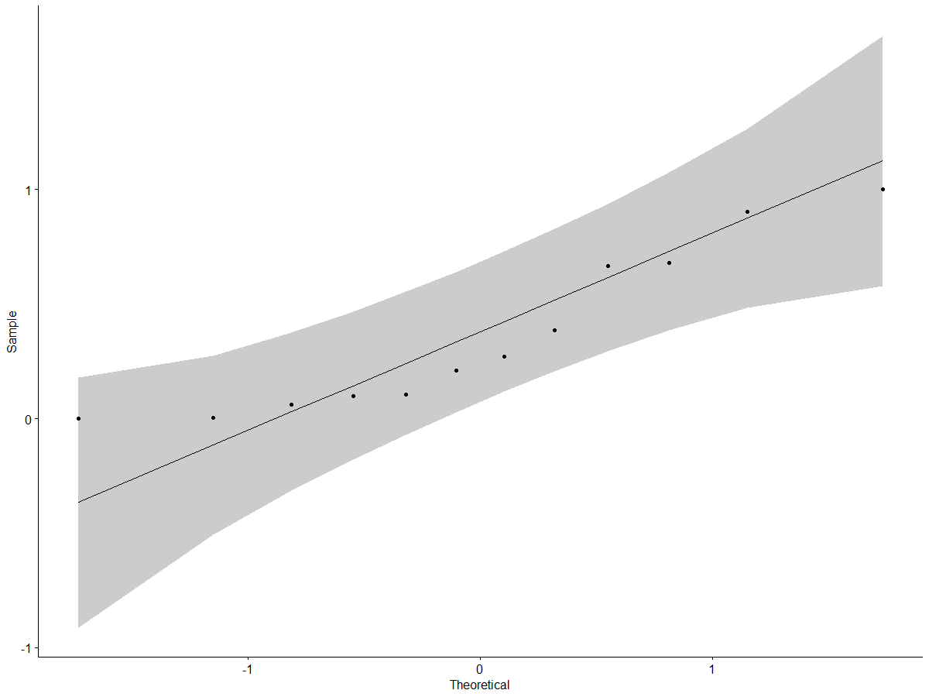

Our samples are very close to the line, and hence we can conclude that this is a normalised data.

## What is the trend of suicides committed by the females in India over the years?

Now, let’s get ready to answer our first question. We have gathered enough data to make conclusions out of them.

# Plot the trend of women commiting suicide  
> library(ggplot2)  
> ggplot(data = aggWomen, aes(x=Category, y=x, col=Category)) +  
+ geom_line()

This will give us the following graph:

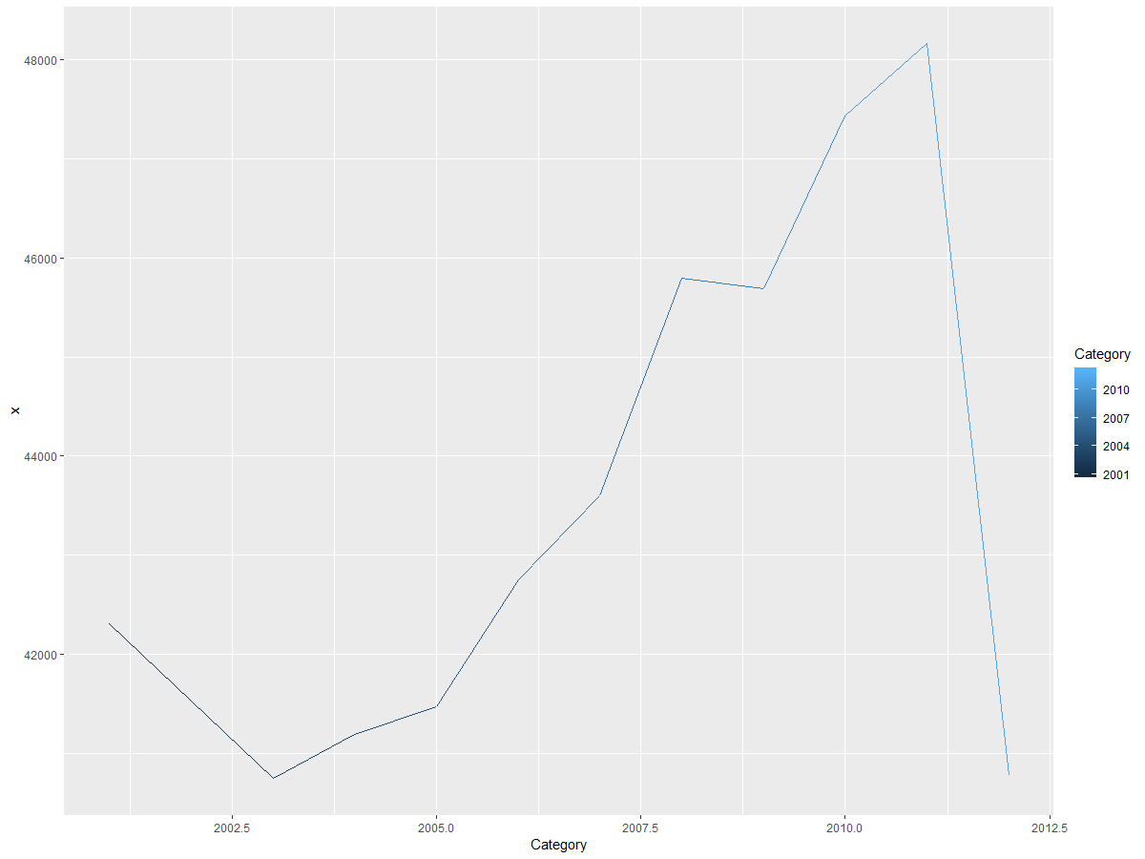

Hence, we conclude that the female suicides had its peak in 2011, and then a drastic drop in 2012. This is, in fact, in sync with the report published by [National Crime Records Bureau](http://ncrb.gov.in/StatPublications/ADSI/ADSI2003/suicidal03.pdf).

## Which age group is more prone to commit suicides?

To answer this question, we need to consider both the genders, throughout the years. And then draw conclusions from this data.

# Number of people committing suicide regardless of thier age  
> ageDied <- encodedData %>%  
+ select(Year, Type_code, Age_group, Total) %>%  
+ filter(Total > 0, Type_code == "Causes")

# Number of people committing suicide per age group per year  
> aggAgeDied <- as.data.frame(aggregate(ageDied$Total, by=list(Category=ageDied$Age_group), FUN=sum))

# Plot the graph of the trends of suicide by age groups  
> barplot(aggAgeDied$x, main="Suicides By Age Group",  
+ names.arg = aggAgeDied$Category,  
+ ylab = "Number of Deaths",  
+ xlab = "Age Group")

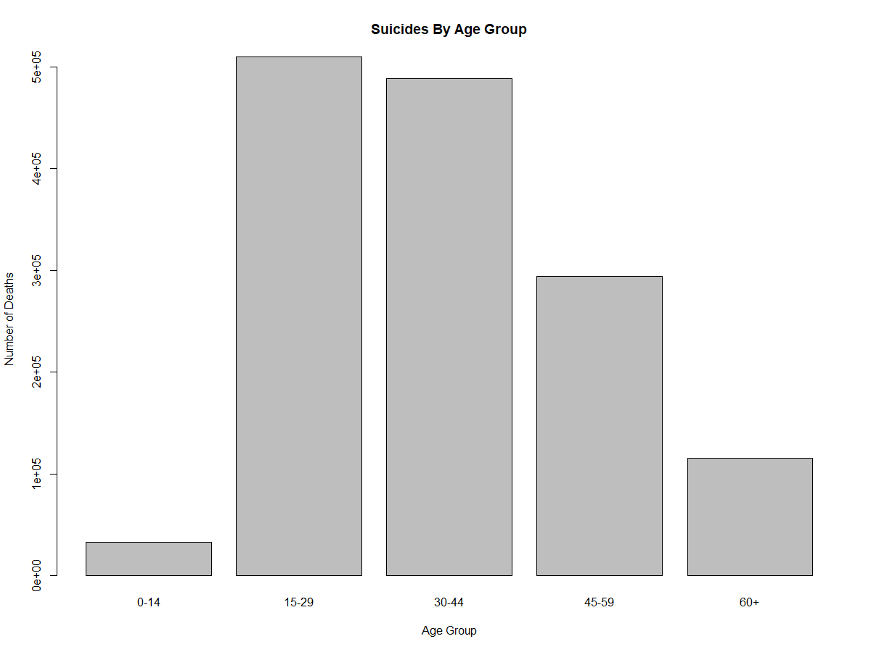

Hence, we conclude that the age group **15-29** and **30-44** are prone to commit suicides the most.

## What is the major cause of suicides in India?

To answer this last question, we need to take a look at all the profiles we collected our data from, group them according to the causes, and plot a pie chart.

# Number of suicides regardless of thier cause  
> peopleDied <- encodedData %>%  
+ select(Year, Type_code, Type, Total) %>%  
+ filter(Total > 0, Type_code == "Causes", Type != "Causes Not known", Type != "Other Causes (Please Specity)")  
  
# Number of students comitting suicide regardless of thier cause per year  
> aggPeopleDied <- as.data.frame(aggregate(peopleDied$Total, + by=list(Category=peopleDied$Type), FUN=sum))

Let’s plot a barplot and a pie chart for our convenience to see which cause has affected the suicides most.

# Plot a bar plot  
> bp<- ggplot(aggPeopleDied, aes(x="", y=aggPeopleDied$x, fill=aggPeopleDied$Category))+  
+ geom_bar(width = 1, stat = "identity")

# Plot a pie chart  
> pie <- bp + coord_polar("y", start=0)

Next page, we show our graph.

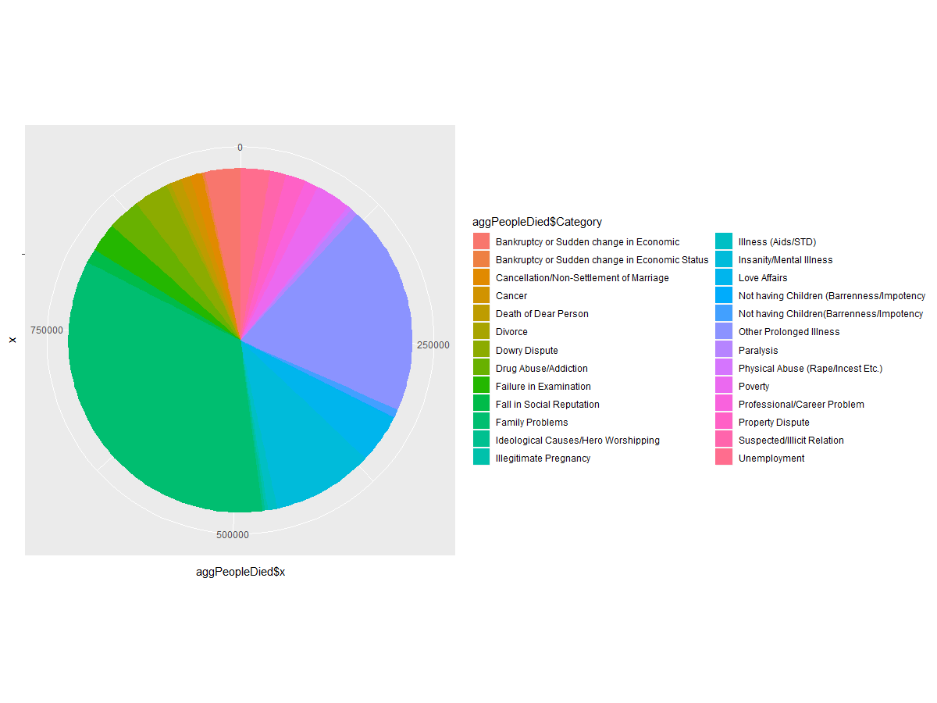

Hence, we conclude that the “**Family Problems**”, “**Other Prolonged Illness**” “**Insanity/Mental Illness**” and “**Love Affairs**” contribute towards suicide the most.

## Correlation

Here, we will try to find out the answer to this question:

**What is the major cause of suicides in Students?**

To answer this question practically, we realise a few roadblocks in our dataset. The column “Type_Code” mentions either *Professional Profile* (which is Student, in our case), or *Causes* (which we need to find out) - both can’t be mentioned together in the same column.

We overcome this problem, by using the method of correlation. That is, relating a third variable with our initial variables so as to get a meaningful insight about our initial problem statement.

In this case, students will mostly fall below 30 years, and hence we can satisfyingly conclude that *age_group* is related to students. If we take a look at the causes of suicide in those age groups, we can conclude the major cause of suicides in students as well.

### Step 1: Find Students’ major age group.

# Number of students died  
> studentsDied <- encodedData %>%  
+ select(Year, Type_code, Age_group, Type, Total) %>%  
+ filter(Total > 0, Type_code == "Professional_Profile", Type == "Student")

# Number of students died per age group  
> aggstudentsDied <- as.data.frame(aggregate(studentsDied$Total, by=list(Category=studentsDied$Age_group), FUN=sum))

This will give us the following data:

|  |  |
| --- | --- |
| Category | x |
| 0-14 | 14619 |
| 15-29 | 56219 |
| 30-44 | 3113 |
| 45-59 | 327 |
| 60+ | 45 |

Hence, we can safely conclude that students belong to 0-29 years of age.

### Step 2: Find the causes of suicide in ages 0-29 years.

To find the causes of suicide in these years, we write the following code.

# People that died in the age group of 0-29  
> ageWisestudentsDied <- encodedData %>%  
+ select(Year, Type_code, Age_group, Type, Total) %>%  
+ filter(Total > 0, Age_group == "0-14" | Age_group == "15-29", Type_code == "Causes", Type != "Causes Not known", Type != "Other Causes (Please Specity)")

# Filtered by their causes  
> aggAgeWisestudentsDied <- as.data.frame(aggregate(ageWisestudentsDied$Total, by=list(Category=ageWisestudentsDied$Type), FUN=sum))

This will give us a table which will have number of suicides per cause. Let’s stick to the top five causes of suicides in these age groups.

# Top 5 reasons to commit suicide  
> aggAgeWisestudentsDied[order(aggAgeWisestudentsDied$x,decreasing=T)[1:5],]

|  |  |
| --- | --- |
| Category | x |
| Family Problems | 125681 |
| Other Prolonged Illness | 52458 |
| Love Affairs | 34273 |
| Insanity/Mental Illness | 28482 |
| Failure in Examination | 25592 |

Therefore, we conclude that these are the **top 5 causes of suicides in students of India**.

### Step 3: Conclusive Analysis

In our previous data table, we found out that the 0-14 and 15-29 age group’s ratio is **0.26**. Which means that majority of these causes belong to 15-29 groups of age. So, we will not individually calculate the causes of death in these groups and then combine them to test our initial hypothesis.

# People that died in the age group of 0-14  
> ageWisestudentsDied2 <- encodedData %>%  
+ select(Year, Type_code, Age_group, Type, Total) %>%  
+ filter(Total > 0, Age_group == "0-14", Type_code == "Causes", Type != "Causes Not known", Type != "Other Causes (Please Specity)")  
# Filtered by their causes  
> aggAgeWisestudentsDied2 <- as.data.frame(aggregate(ageWisestudentsDied2$Total, + by=list(Category=ageWisestudentsDied2$Type), FUN=sum))  
# Top 5 reasons to commit suicide  
> aggAgeWisestudentsDied2[order(aggAgeWisestudentsDied2$x,decreasing=T)[1:5],]

|  |  |
| --- | --- |
| Category | x |
| Failure in Examination | 4264 |
| Family Problems | 4254 |
| Other Prolonged Illness | 2252 |
| Love Affairs | 1250 |
| Insanity/Mental Illness | 1223 |

Here, we find that the major cause of worry is the Failure in Examinations and Family problems, along with illnesses.

# People that died in the age group of 15-29  
> ageWisestudentsDied3 <- encodedData %>%  
+ select(Year, Type_code, Age_group, Type, Total) %>%  
+ filter(Total > 0, Age_group == "15-29", Type_code == "Causes", Type != "Causes Not known", Type != "Other Causes (Please Specity)")  
# Filtered by their causes  
> aggAgeWisestudentsDied3 <- as.data.frame(aggregate(ageWisestudentsDied3$Total, + by=list(Category=ageWisestudentsDied3$Type), FUN=sum))  
# Top 5 reasons to commit suicide  
> aggAgeWisestudentsDied3[order(aggAgeWisestudentsDied3$x,decreasing=T)[1:5],]

|  |  |
| --- | --- |
| Category | x |
| Family Problems | 121427 |
| Other Prolonged Illness | 50206 |
| Love Affairs | 33023 |
| Insanity/Mental Illness | 27259 |
| Dowry Dispute | 23020 |

Here, we find that the major cause of worry is the Family Problems, illnesses and Love Affairs. Hence from the above two studies, we conclude that:

**Failure in Examination, Family Problems, Illness,** and **Love Affairs** are the major causes of suicides in Students.

## Hypothesis Testing

H0 : Each year, **more than 30%** of people commit suicide because of **Family Problems**.

H1 : **Less than 30%** of people commit suicide because of Family Problems.

### Step 1: Group dataset by year, type and total number of suicides by that type.

# Find total number of deaths by cause  
> library(plyr)  
> groupColumns = c("Year","Type")  
> dataColumns = c("Total")  
> res <- ddply(hyp_died, groupColumns, function(x) colSums(x[dataColumns]))

### Step 2: Find total number of suicides per year.

# Total number of suicides per year  
> hyp_grouped <- aggregate(res$Total, by=list(Category=res$Year), FUN=sum)

### Step 3: Add this data to the *res* data frame.

# Add total number of deaths in year to res  
> res <- res %>%  
+ rowwise %>%  
+ do({  
+ result = as_data_frame(.)  
+ result$TotalDied = hyp_grouped[hyp_grouped$Category == result$Year, 2] + result  
+ })

### Step 4: Find percentage cause of each suicide.

# Find percentage cause of each suicide.  
> res <- res %>%  
+ rowwise %>%  
+ do({  
+ result = as_data_frame(.)  
+ result$Percentage = (result$Total/(result$TotalDied))*100  
+ Result  
+ })

### Step 5: Find percentage of suicides by Family Problems each year.

# Find percentage of suicides by Family Problems each year.  
> hyp_familyProblems <- res %>%  
+ filter(Total > 0, Type == "Family Problems")

|  |  |  |  |  |
| --- | --- | --- | --- | --- |
| Year | Type | Total | TotalDied | Percentage |
| 2001 | Family Problems | 24162 | 74067 | 32.62182 |
| 2002 | Family Problems | 25085 | 75891 | 33.05399 |
| 2003 | Family Problems | 26308 | 78419 | 33.54799 |
| 2004 | Family Problems | 25531 | 78690 | 32.44504 |
| 2005 | Family Problems | 25441 | 77022 | 33.03082 |
| 2006 | Family Problems | 30771 | 85675 | 35.91596 |
| 2007 | Family Problems | 29238 | 84575 | 34.5705 |
| 2008 | Family Problems | 29777 | 86225 | 34.53407 |
| 2009 | Family Problems | 30082 | 85364 | 35.23968 |
| 2010 | Family Problems | 31856 | 90476 | 35.20934 |
| 2011 | Family Problems | 32909 | 89927 | 36.59524 |
| 2012 | Family Problems | 30792 | 81524 | 37.77047 |

### 

### Step 5: Test the hypothesis.

# Use t-test to find out if hypothesis is true or not  
> summary(hyp_familyProblems$Percentage)  
> t.test(hyp_familyProblems$Percentage

This will print the following output:

> summary(hyp_familyProblems$Percentage)  
 Min. 1st Qu. Median Mean 3rd Qu. Max.   
 32.45 33.05 34.55 34.54 35.41 37.77   
> t.test(hyp_familyProblems$Percentage, mu = 30, alternative = "less")  
  
 One Sample t-test  
  
data: hyp_familyProblems$Percentage  
t = 9.3733, df = 11, p-value = 1  
alternative hypothesis: true mean is less than 30  
95 percent confidence interval:  
 -Inf 35.4153  
sample estimates:  
mean of x   
 34.54458

## Hypothesis Conclusion

The **p-value is 1**, which clearly suggests that our hypothesis is true with **95% confidence.**

In other words, **We are 95% confident that more than 30% of people commit suicide because of family problems each year.**